Student Name: Daniel Harris

Student Number: 10556318

Game Name: Don’t miss that promotion

Controls:

PC - WASD/Arrow key

Xbox Controller

Mobile - Touch buttons

Tools:

Management - Trello

Repo - GitHub

Modelling - 3ds Max

Coding - Visual Studio

Engine - Unity

YouTube - Tutorials

Target Platform: PC, Mobile

I plan to release the game on PC because having it online can help with distribution and an online profile. With the game being on PC, the controls will be designed for a controller which can be plugged into the computer and by releasing the game on mobile I will be able to implement touch controls or tilt features.

Target Audience:

The game will be designed for young teenagers and above due to the ability to drive and crash into other cars. Due to the cartoon style I can estimate the age range would be between 12-22 depending on how much the user enjoys driving games.

Story:

You’ve spent several months working towards a big promotion and today is the big day, where the head honcho assigns his replacement. You know that your most competitive co-worker has been trying their best to take the job for themselves. On your way to work, you pull up to a set of traffic lights and in the car next to you sits your rival.

Waiting for the lights to turn green, your co-worker sits bolt upright, one hand on the wheel and the other ready on the gear stick. They are not waiting around, as soon as the green light goes, it’s a race to work.

Inspiration:

The main sauce of inspiration for the game has come from Mario kart and other cartoon racers. This is because from personal experience, cartoon racers provide the most entertaining racing experience. I wanted the game to also be designed around a 2-player mechanic meaning you will be racing a friend to the end dodging and weaving through traffic.

The concept behind the game is to get players to plan their route and think about the direction they are going and about the obstacles in the way. This will be challenged each time because each time the game is loaded up the speed for each NPC car will be different providing a level of replayability and meaning that experienced players will only know how the car drives and the road layout but not the positioning of the other cars.

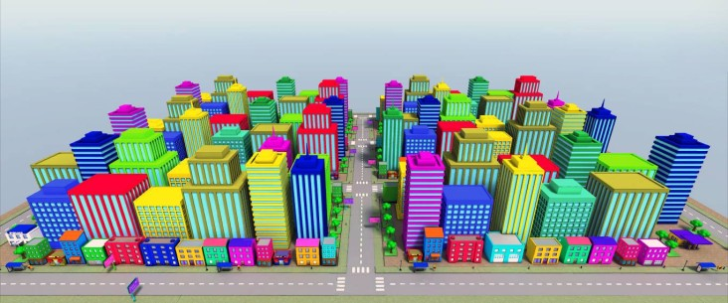

(TKstudio, 2015)

This city has the exact art style that I am looking for but due to the price tag, I will use it as inspiration rather than using the models.

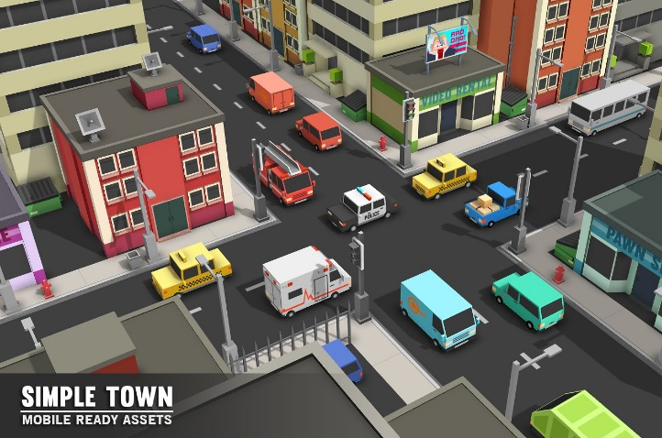

The image on the right has inspired me to use large cartoon cars with small single road streets because this will give the player a harder time driving through the streets. With these inspirational images I can deduce that the city I will be creating will be compact yet clean and simple, making sure that the players attention isn’t taken away from the race.

(creativemarket, 2016)

Specific Mechanic:

For the game, the mechanic that I wanted to focus on was the driving aspect of the game. This then developed into refining the concept and aiming towards drifting but through further development the drifting mechanic faded away by trying to implement a city scene with narrow roads and obstacles. The mechanic has altered into a race to the finish while avoiding moving NPCs.

Assets:

Within Unity there is the option to use already created assets and since the aim is to produce a successful mechanic, I have used an online asset pack which contains simply cartoon models of cars and building. Then within unity, using these models to create a realistic and understandable city scape.

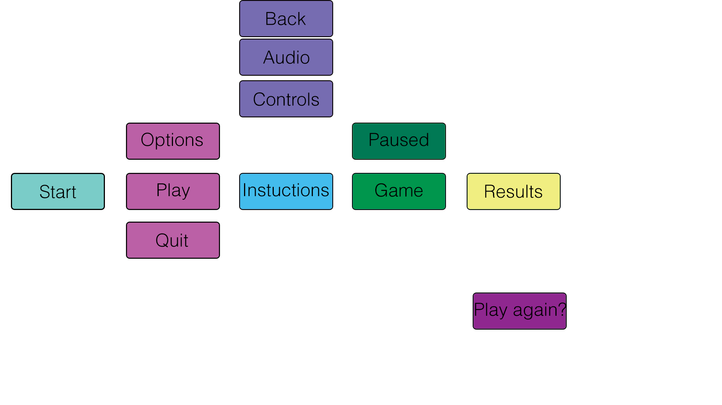

# Bibliography

creativemarket. (2016, 6 21). *Simple Town - Cartoon City Assests*. From Creative Market: https://creativemarket.com/SyntyStudios/219719-Simple-Town-Cartoon-City-Assets

TKstudio. (2015, 11 1). *Cartoon City Pack*. From TKstudio: https://tkstudio.ninja/?mg_items=cartoon-city-pack